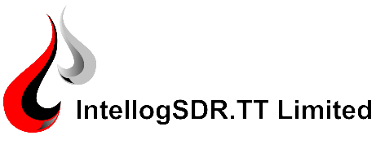

Job Title: Data Engineer
Company: IntellogSDR.TT Limited
Job Description:
IntellogSDR.TT Limited is actively seeking an experienced Data Engineer with a focus on mud logging. This specialized role involves designing, developing, and implementing data systems tailored to the oil and gas industry, with a specific emphasis on mud logging. The successful candidate will be responsible for expanding and optimizing our data architecture, as well as optimizing data flow and collection for cross-functional teams.
Responsibilities:
- Develop and maintain data systems and infrastructure tailored to mud logging operations.
- Assemble complex data sets that meet functional/non-functional business requirements within the context of mud logging.
- Identify, design, and implement internal process improvements in mud logging data processes: automate manual processes, optimize data delivery, and redesign infrastructure for greater scalability.
- Collaborate with geologists, drilling engineers, and other professionals to ensure optimal data collection and usage within the mud logging scope.
- Ensure data segregation and security across different operations, adhering to industry and company standards.
- Provide timely and relevant data to support decision-making processes in drilling operations.
- Implement quality control measures on all mud logging data.
- Utilize advanced analytic skills to interpret complex data related to drilling and mud logging operations.
Qualifications:
- BASc Degree in either Engineering or Computer Science from a recognized institution.
- A minimum of 5 years of experience in a Data Engineer role, specifically within the oil and gas industry, and with a focus on mud logging.
- Experience with mud logging software and tools.
- Strong understanding of geology, drilling operations, and associated data.
- Strong analytic skills related to working with unstructured datasets.
How to Apply:
If you meet the above criteria and are interested in this opportunity, we would love to hear from you. Please apply with your resume and a cover letter to our HR department at mls.tt@intellogsdr.com by July 31, 2023.
IntellogSDR.TT Limited is an equal opportunity employer. We celebrate diversity and are committed to creating an inclusive environment for all employees. We thank all applicants for their interest; however, only those candidates selected for an interview will be contacted.
(Note: Always ensure to follow local labor laws and regulations when crafting a job posting)

